Practical 8

Start with HBase Shell
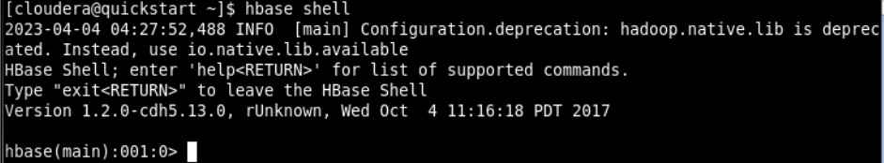

Create a HBase table named ‘Student’ with column families StudID, StudName and StudAddress. Also cross check the creation and schema details of the table.
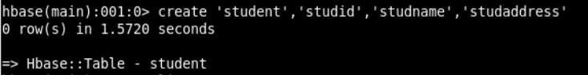
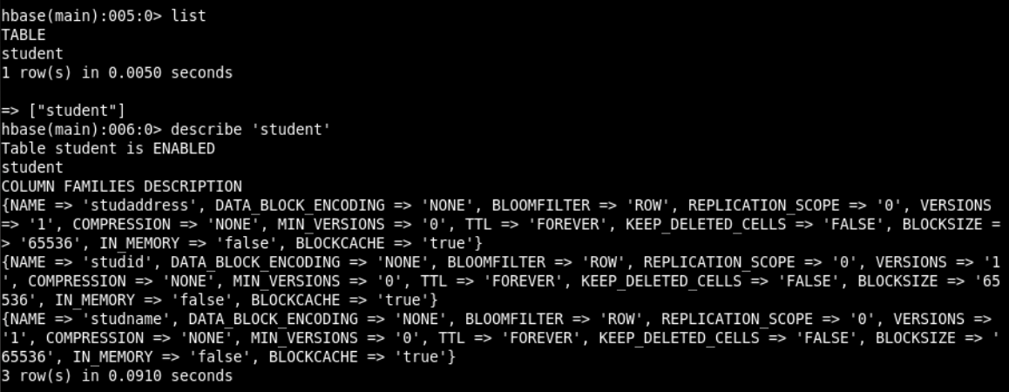

Insert following data into the student table.
Syntax: put 'Student','S01','StudName:FName','Amit' )
S01,Amit Prakash Vaze, Mulund
S02,Sumit Neeraj Kulkarni, Devi Dayal Road, Mulund W
S03,Alka Deepak Yadav, PK Road, Thane, Maharashtra
S04,Amit Neeraj Yadav, Goshala Road, Mulund W, Maharashtra
S05,Veena Pushkar Mhatre, JN Road, Thane W, Maharashtra

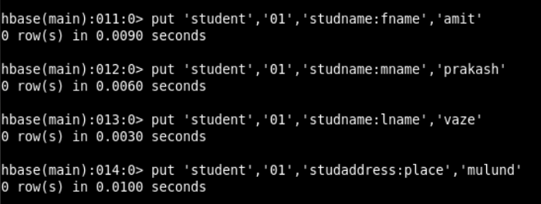
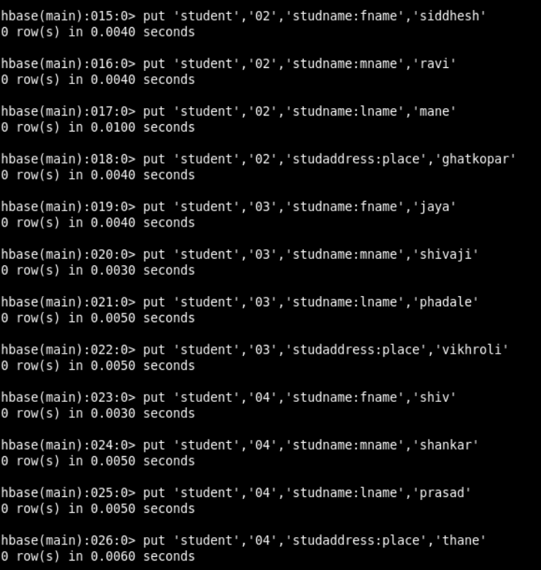

Display all rows from the Student table. (scan command)
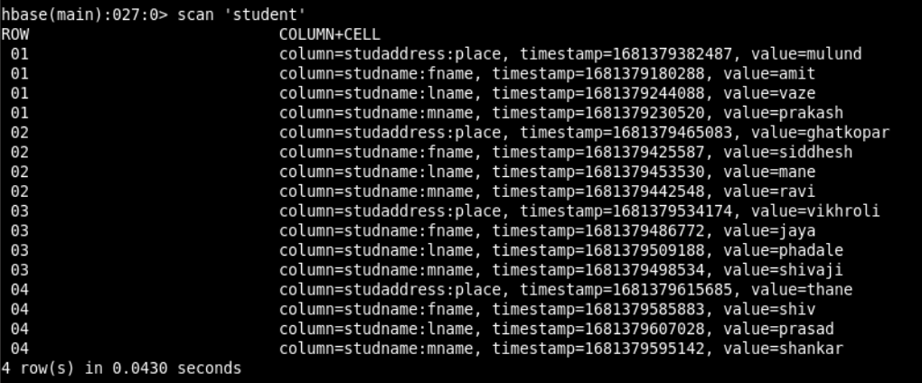

Display address list of all students. (get command)
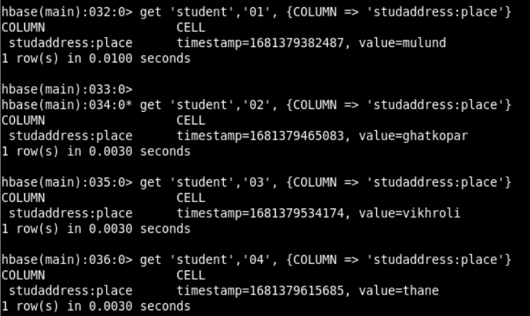

Display list of students.
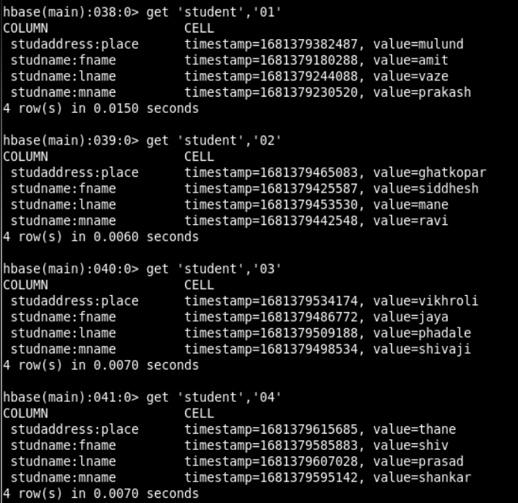

To get a particular list
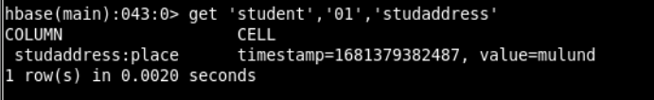

Display total number of students.
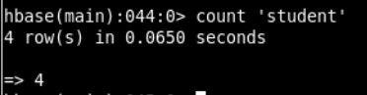

Disable Student table and display the table schema using describe command.
Syntax: >disable ‘Student’
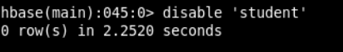

Check disabled status of the table using is-disabled command.
Syntax: >is_disabled ‘Student’
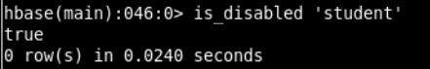

Enable Student table and display the table schema.
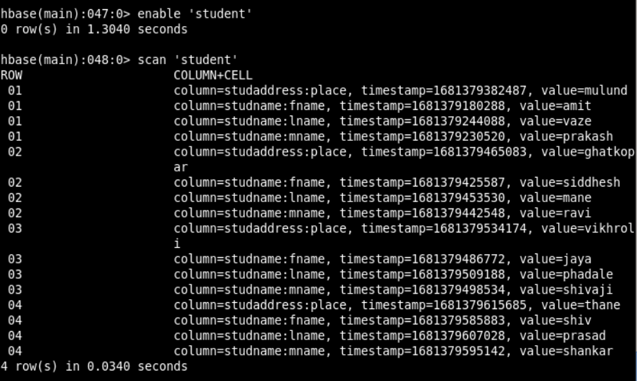

Demonstrate the deletion of column values and a row.
- Deleting a specific cell
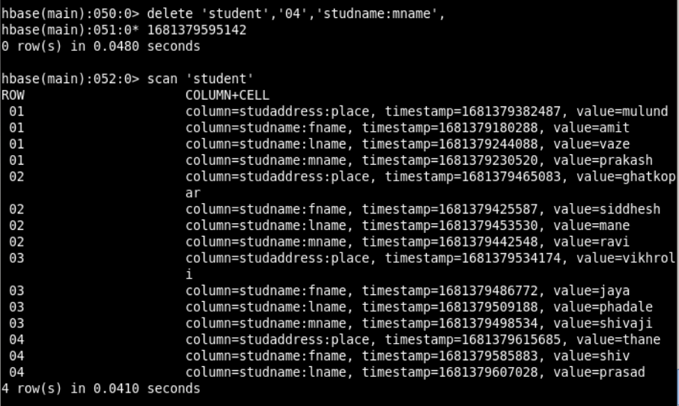

- Deleting all cells
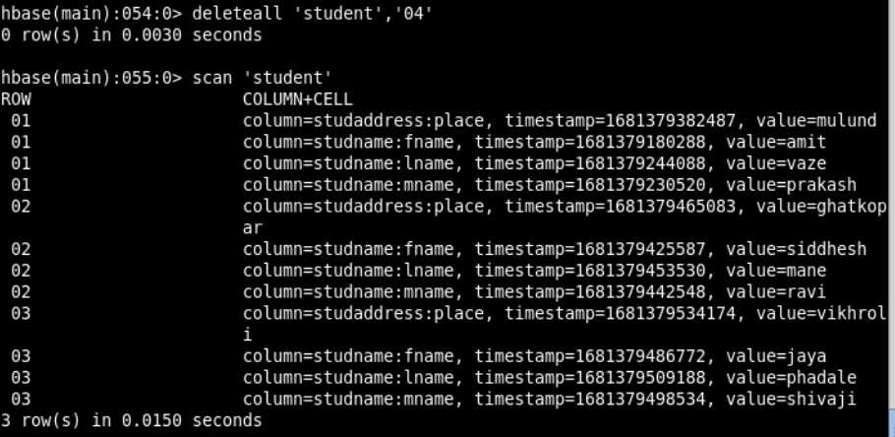

Set the maximum number of cell changes to 5.
Syntax: >alter ‘Student’, Name=’NewColFamily’, VERSIONS=>5
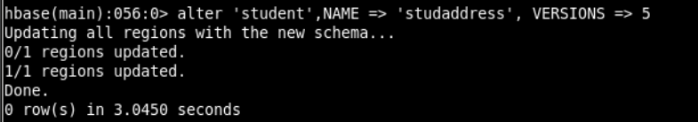

Delete column family ‘Address’ from Student table.
Syntax: >alter ‘Student’,‘delete’ => ‘Address’
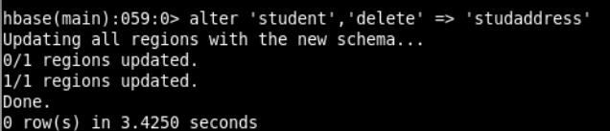

Check the existence of the Student table.
Syntax: >exists table_name
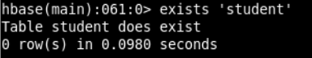

Drop Table ‘Student’
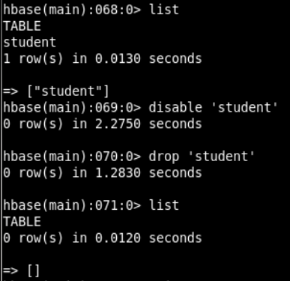

Checking if the table exists
